SEC Form 4
FORM 4 |  | UNITED STATES SECURITIES AND EXCHANGE COMMISSION  Washington, D.C. 20549  STATEMENT OF CHANGES IN BENEFICIAL OWNERSHIP  Filed pursuant to Section 16(a) of the Securities Exchange Act of 1934  or Section 30(h) of the Investment Company Act of 1940
  OMB APPROVAL
  OMB Number: | 3235-0287
  Estimated average burden
  hours per response: | 0.5
 | Check this box if no longer subject to Section 16. Form 4 or Form 5 obligations may continue. See Instruction 1(b).
 | Check this box to indicate that a transaction was made pursuant to a contract, instruction or written plan for the purchase or sale of equity securities of the issuer that is intended to satisfy the affirmative defense conditions of Rule 10b5-1(c). See Instruction 10.
1. Name and Address of Reporting Person*  (Street) | 2. Issuer Name and Ticker or Trading Symbol  People Inc [ PPLI ]  Foreign Trading Symbol | 5. Relationship of Reporting Person(s) to Issuer  (Check all applicable)
  Lourd Bryan
  (Last) | (First) | (Middle)
  C/O CAA
  2000 AVENUE OF THE STARS
  LOS ANGELES | CA | 90067
  (City) | (State) | (Zip)
   | Director |  | 10% Owner
   | Officer (give title below) |  | Other (specify below)
3. Date of Earliest Transaction (Month/Day/Year)
09/30/2026
 | 4. If Amendment, Date of Original Filed (Month/Day/Year) | 6. Individual or Joint/Group Filing (Check Applicable Line)
  Form filed by One Reporting Person
  Form filed by More than One Reporting Person
Table I - Non-Derivative Securities Acquired, Disposed of, or Beneficially Owned
1. Title of Security (Instr. 3) | 2. Transaction Date (Month/Day/Year) | 2A. Deemed Execution Date, if any (Month/Day/Year) | 3. Transaction Code (Instr. 8) |  | 4. Securities Acquired (A) or Disposed Of (D) (Instr. 3, 4 and 5) |  |  | 5. Amount of Securities Beneficially Owned Following Reported Transaction(s) (Instr. 3 and 4) | 6. Ownership Form: Direct (D) or Indirect (I) (Instr. 4) | 7. Nature of Indirect Beneficial Ownership (Instr. 4)
1. Title of Security (Instr. 3) | 2. Transaction Date (Month/Day/Year) | 2A. Deemed Execution Date, if any (Month/Day/Year) | Code | V | Amount | (A) or (D) | Price |  | 6. Ownership Form: Direct (D) or Indirect (I) (Instr. 4) | 7. Nature of Indirect Beneficial Ownership (Instr. 4)
Common Stock, par value $0.0001(1) | 09/30/2026 |  | A |  | 387 | A | $41.96 | 178,402(2) | D
Common Stock, par value $0.0001 |  |  |  |  |  |  |  | 26,235(2) | I | Through a trust, of which the reporting person is trustee
Table II - Derivative Securities Acquired, Disposed of, or Beneficially Owned
(e.g., puts, calls, warrants, options, convertible securities)
1. Title of Derivative Security (Instr. 3) | 2. Conversion or Exercise Price of Derivative Security | 3. Transaction Date (Month/Day/Year) | 3A. Deemed Execution Date, if any (Month/Day/Year) | 4. Transaction Code (Instr. 8) |  | 5. Number of Derivative Securities Acquired (A) or Disposed of (D) (Instr. 3, 4 and 5) |  | 6. Date Exercisable and Expiration Date (Month/Day/Year) |  | 7. Title and Amount of Securities Underlying Derivative Security (Instr. 3 and 4) |  | 8. Price of Derivative Security (Instr. 5) | 9. Number of derivative Securities Beneficially Owned Following Reported Transaction(s) (Instr. 4) | 10. Ownership Form: Direct (D) or Indirect (I) (Instr. 4) | 11. Nature of Indirect Beneficial Ownership (Instr. 4)
 |  |  |  | Code | V | (A) | (D) | Date Exercisable | Expiration Date | Title | Amount or Number of Shares
Explanation of Responses:
1. Represents share units accrued under the Non-Employee Director Deferred Compensation Plan as of the date of this report.
2. On July 27, 2026, the Reporting Person transferred 26,235 shares of Issuer common stock to a trust for no consideration, which transfer is exempt from reporting pursuant to Rule 16-a-13. The Reporting Person remains the beneficial owner of the securities held by the trust.
Remarks:
Exhibit 24 - Power of Attorney
 | /s/ Tara Hereich as Attorney-In-Fact for Bryan Lourd | 10/02/2026
 | ** Signature of Reporting Person | Date
Reminder: Report on a separate line for each class of securities beneficially owned directly or indirectly.
* If the form is filed by more than one reporting person, see Instruction 4 (b)(v).
** Intentional misstatements or omissions of facts constitute Federal Criminal Violations See 18 U.S.C. 1001 and 15 U.S.C. 78ff(a).
Note: File three copies of this Form, one of which must be manually signed. If space is insufficient, see Instruction 6 for procedure.
Persons who respond to the collection of information contained in this form are not required to respond unless the form displays a currently valid OMB Number.
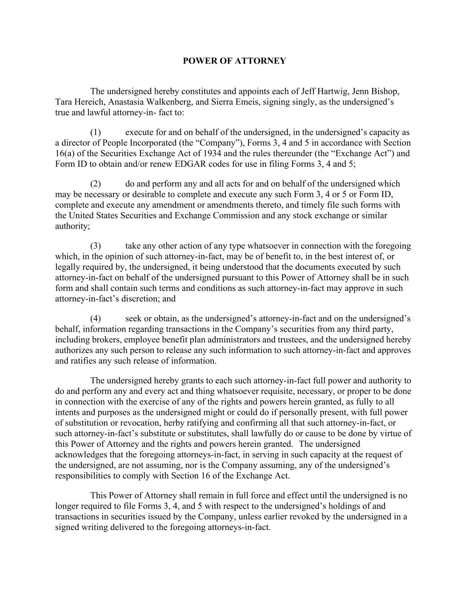
POWER OF ATTORNEY The undersigned hereby constitutes and appoints each of Jeff Hartwig, Jenn Bishop, Tara Hereich, Anastasia Walkenberg, and Sierra Emeis, signing singly, as the undersigned’s true and lawful attorney-in- fact to: (1) execute for and on behalf of the undersigned, in the undersigned’s capacity as a director of People Incorporated (the “Company”), Forms 3, 4 and 5 in accordance with Section 16(a) of the Securities Exchange Act of 1934 and the rules thereunder (the “Exchange Act”) and Form ID to obtain and/or renew EDGAR codes for use in filing Forms 3, 4 and 5; (2) do and perform any and all acts for and on behalf of the undersigned which may be necessary or desirable to complete and execute any such Form 3, 4 or 5 or Form ID, complete and execute any amendment or amendments thereto, and timely file such forms with the United States Securities and Exchange Commission and any stock exchange or similar authority; (3) take any other action of any type whatsoever in connection with the foregoing which, in the opinion of such attorney-in-fact, may be of benefit to, in the best interest of, or legally required by, the undersigned, it being understood that the documents executed by such attorney-in-fact on behalf of the undersigned pursuant to this Power of Attorney shall be in such form and shall contain such terms and conditions as such attorney-in-fact may approve in such attorney-in-fact’s discretion; and (4) seek or obtain, as the undersigned’s attorney-in-fact and on the undersigned’s behalf, information regarding transactions in the Company’s securities from any third party, including brokers, employee benefit plan administrators and trustees, and the undersigned hereby authorizes any such person to release any such information to such attorney-in-fact and approves and ratifies any such release of information. The undersigned hereby grants to each such attorney-in-fact full power and authority to do and perform any and every act and thing whatsoever requisite, necessary, or proper to be done in connection with the exercise of any of the rights and powers herein granted, as fully to all intents and purposes as the undersigned might or could do if personally present, with full power of substitution or revocation, herby ratifying and confirming all that such attorney-in-fact, or such attorney-in-fact’s substitute or substitutes, shall lawfully do or cause to be done by virtue of this Power of Attorney and the rights and powers herein granted. The undersigned acknowledges that the foregoing attorneys-in-fact, in serving in such capacity at the request of the undersigned, are not assuming, nor is the Company assuming, any of the undersigned’s responsibilities to comply with Section 16 of the Exchange Act. This Power of Attorney shall remain in full force and effect until the undersigned is no longer required to file Forms 3, 4, and 5 with respect to the undersigned’s holdings of and transactions in securities issued by the Company, unless earlier revoked by the undersigned in a signed writing delivered to the foregoing attorneys-in-fact.

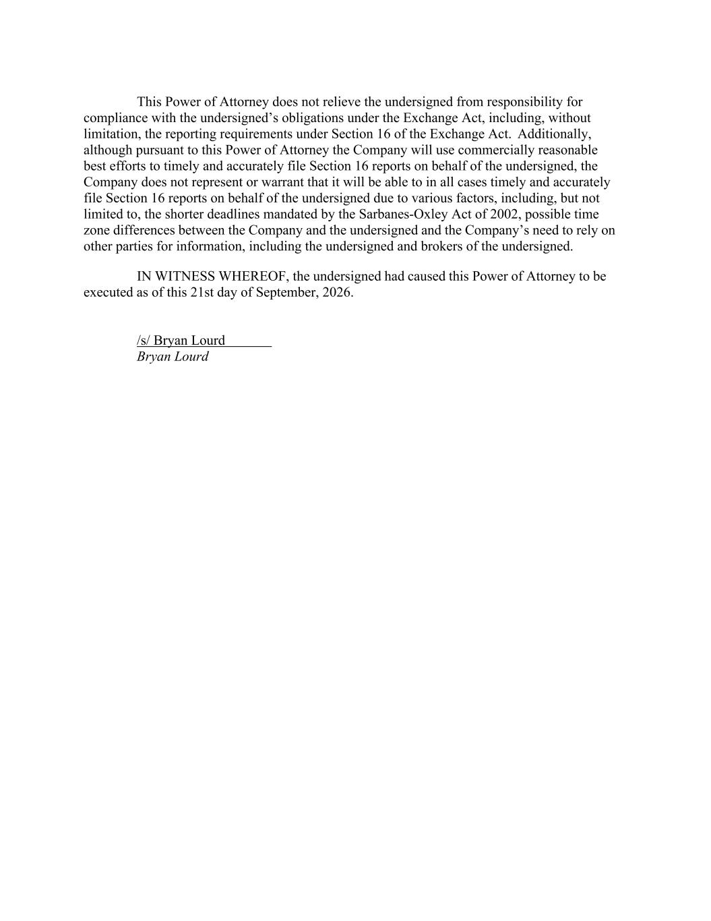
This Power of Attorney does not relieve the undersigned from responsibility for compliance with the undersigned’s obligations under the Exchange Act, including, without limitation, the reporting requirements under Section 16 of the Exchange Act. Additionally, although pursuant to this Power of Attorney the Company will use commercially reasonable best efforts to timely and accurately file Section 16 reports on behalf of the undersigned, the Company does not represent or warrant that it will be able to in all cases timely and accurately file Section 16 reports on behalf of the undersigned due to various factors, including, but not limited to, the shorter deadlines mandated by the Sarbanes-Oxley Act of 2002, possible time zone differences between the Company and the undersigned and the Company’s need to rely on other parties for information, including the undersigned and brokers of the undersigned. IN WITNESS WHEREOF, the undersigned had caused this Power of Attorney to be executed as of this 21st day of September, 2026. /s/ Bryan Lourd Bryan Lourd

